

V 1.0
May 2026
XStep Design Specification
SMPL: Solution Summary - Data Recording Var

Table of Contents
Right-click and choose Update Field to build the table of contents.

Purpose
This document outlines the functional and technical design, along with the configuration specifications for the XStep “SMPL: Solution Summary - Data Recording Var”.
This XStep facilitates the recording of critical process parameters—such as temperature and conductivity for example—during Electronic Batch Record (EBR) execution. It is configured to retrieve data directly from connected process equipment or, where automation is not available, allows for manual data entry. The step is fully integrated with the SAP Equipment Master and equipment logbook records, supporting equipment traceability and compliance.

Overview
Operators can select from pre-assigned, qualified equipment, ensuring alignment with manufacturing phase requirements. Parameter limits (minimum and maximum values) are predefined in the SAP Production Version, and built-in system validations verify that recorded values fall within the acceptable range before allowing the process to continue.
This XStep plays a key role in maintaining batch integrity, ensuring traceability, and enabling real-time process monitoring.
The XStep contains several main input parameters:
- IV_HEADER - This can be changed in SiMPL MBR to display specific header text for the XStep
- IV_INSTR - This can be changed in SiMPL MBR to display a specific set of instructions for the XStep that will be displayed below the header
- IV_DES - This can be changed in SiMPL MBR to display a specific description of the parameter to be recorded
- IV_MIN - This can be changed in SiMPL MBR to configure the Minimum validation range of the parameter to be recorded
- IV_MAX - This can be changed in SiMPL MBR to configure the Maximum validation range of the parameter to be recorded
- IV_UOM_T - This can be changed in SiMPL MBR to display a specific Unit of Measure of the parameter to be recorded
- IV_EQ_CAT - This must be configured in SiMPL MBR to allow the selection of the equipment based on a specific equipment category as set for equipment in the Equipment Master
- IV_OBJ_TYP - This must be configured in SiMPL MBR to allow the selection of the equipment based on a specific equipment object type as set for equipment in the Equipment Master
- IV_SIGN - This can be changed in SiMPL MBR to select the required signature.

The following fields are auto populated in the Xstep:
- “Min” - Output field as recorded in SiMPL MBR.
- “Max” - Output as authored from SiMPL MBR
- “UoM” - Output as authored from SiMPL MBR
The operator executes the “Select Equipment” button:
- Select Equipment - Function Button
The button is linked to the function module ZSMPL_FM_GET_ASSIGNED_EQUI_EBR that verifies the equipment number against the Equipment Master and retrieves the following information:
- “Equipment ID” - Input short text field
- “Equipment Description” - Output

The operator enters the data reading:
- “Results” - Input Numeric field
To ensure process control, the system performs a real-time validation check to verify that the entered value falls between the minimum (IV_MIN) and maximum (IV_MAX) range. If a recorded value falls outside these boundaries, the system automatically triggers a deviation and generates an error message, preventing the operator from completing the "Performed By" sign-off until the exception is addressed.
If the result is within the minimum and maximum range, the operator can sign off in the "Performed By" field.
In Variant 2, the Select Equipment button and the Equipment ID and Description fields have been removed. This streamlines data entry for instances where specific equipment is not required.
Functional Design
Two variants of the same SMPL: Solution Summary - Data Recording XStep include:
SMPL: Solution Summary - Data Recording
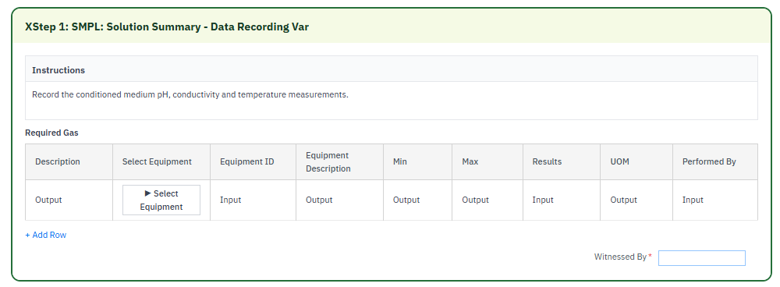
SMPL: Solution Summary - Data Recording W/O Equipment
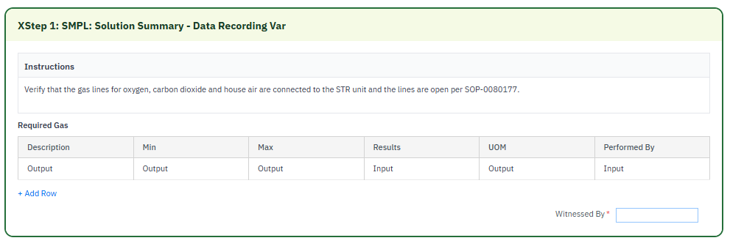

Reasons for developing
This SMPL: Solution Summary - Data Recording Var XStep was developed to ensure accurate and GMP-compliant recording of key process parameters, such as temperature and conductivity. It reduces manual errors, enforces validation rules, and ensures traceability through integration with SAP master data and equipment logbook records.

Authorization
N/A

Assumptions/ Dependencies
 | Assumption
1 | User signing signature fields is an approved user in the system with the correct access configuration
2 | Master Data has been set up correctly
3 | The function modules are available and returns the equipment details
4 | The function module can successfully pull the data into the output fields
5 | The function module has access to the Master Data and Logbooks
6 | The XStep validates key user input fields to ensure that recorded results fall within predefined minimum and maximum limits

Validation Checks
Error Handling
Error | Action
Equipment item not found | Check Equipment Master
User Signature rejected due to an incorrect username or password | User accepts error message and re-enter the correct username and password
Mandatory field data not captured | A validation error is displayed - capture mandatory fields.
Value outside of the tolerance range is accepted. | Verify if tolerance ranges have been correctly authored in SiMPL MBR.

XStep Layout Design
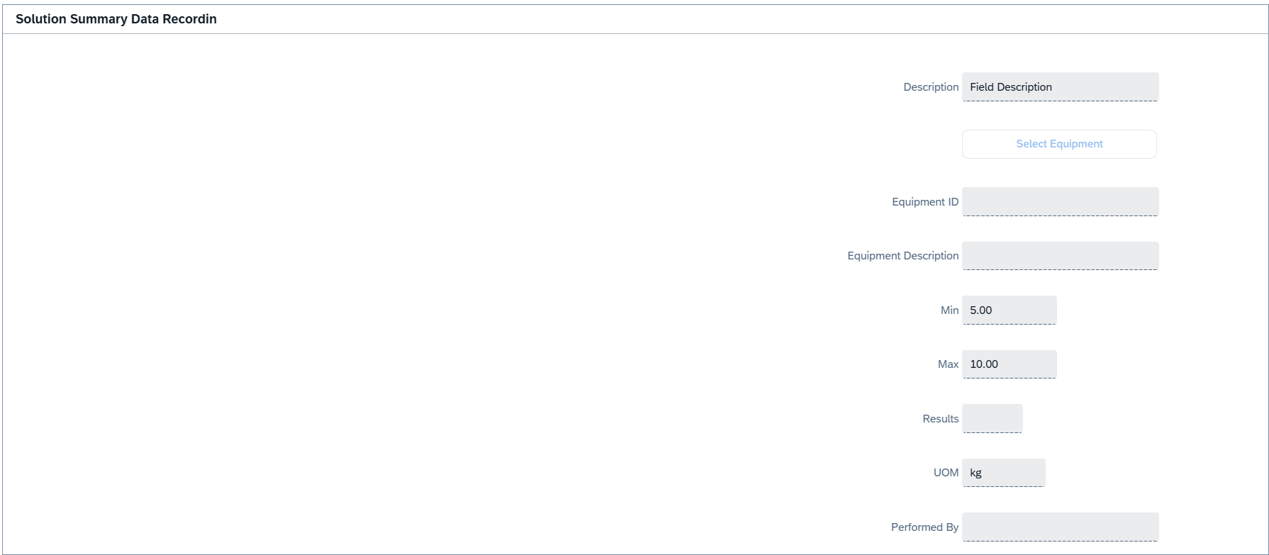
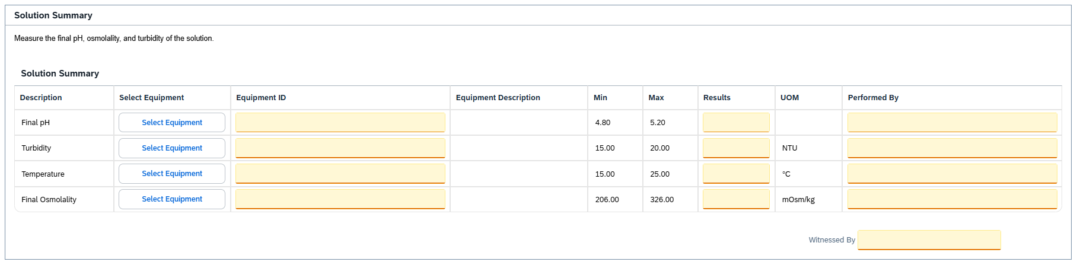

Function Module(s)
Function: ZSMPL_FM_GET_ASSIGNED_EQUI_EBR
Import Parameters:
Parameter Name | Associated Type | Short Text
IM_ORDER | AUFNR | Order Number
IM_EQUIP_TYPE | EQTYP | Equipment Category
IM_ALLOW_NA | BOOLE_D | Boolean variable (allow N/A)
IM_VORNR | VORNR | Operation/Activity Number
IM_OBJ_TYP | EQART | Object Type of Technical Object

Export Parameters:
Parameter Name | Associated Type | Short Text
EX_EQUI | CHAR30 | Equipment ID
EX_EQUI_TXT | CHAR30 | Equipment Description

Exceptions:
Exception | Short Text
INTERNAL_ERROR | Internal processing error

Function: /SMPL/ELB_FM_GET_ASS_EQ_VALID
Import Parameters:
Parameter Name | Associated Type | Short Text
IM_ORDER | AUFNR | Order Number
IM_EQUIP_TYPE | EQTYP | Equipment Category
IM_ALLOW_NA | BOOLE_D | Boolean variable (allow N/A)
IM_EQUI | CHAR30 | Equipment ID to validate
IM_VORNR | VORNR | Operation/Activity Number
IM_MULTI_PO | ABAP_BOOL | Boolean (multi-PO assignment)
IM_CRID | POC_DOCID | Control Recipe Number

Export Parameters:
Parameter Name | Associated Type | Short Text
EX_EQUI_TXT | CHAR30 | Equipment Description

Exceptions:
Exception | Short Text
EQUI_NOT_ASSIGNED | Equipment is not assigned to the order
EQUI_NOT_CLEAN | Equipment is not in a clean status
STATUS_NOT_CONFIGURED | Equipment status configuration is missing

Function: /SMPL/PPPI_FM_MIN_MAX
Import Parameters:
Parameter Name | Associated Type | Short Text
I_MIN | F | Floating Point Number (minimum)
I_MAX | F | Floating Point Number (maximum)
I_VALUE | F | Floating Point Number (value to check)

Exceptions:
Exception | Short Text
VALUE_OUT_OF_RANGE | Entered value falls outside the defined range
MIN_GREATER_THAN_MAX | Minimum value is greater than or equal to the maximum

Function: /SMPL/PPPI_FM_SIG_ADD_DB_CB
Import Parameters:
Parameter Name | Associated Type | Short Text
IM_CONTROL_RECIPE | POC_DOCID | Control Recipe Number
IM_PHASE | VORNR | Activity Number
IM_STEP_IDX | INT4 | XStep Step Index Number
IM_STEP | CHAR30 | XStep Header
IM_SIGTYPE | CHAR20 | Signature Type
IM_USERID | XUBNAME | User Name
IM_DB_UP_DOWN | CHAR1 | Done By Up/Down
IM_VALIDATION_REQ | CHAR3 | Validation Required
IM_STEP_UUID | ZSMPL_DE_SMPL_SOG_UUID | XStep SOG UUID

Function: /SMPL/PPPI_FM_SIG_VALIDATION
Import Parameters:
Parameter Name | Associated Type | Short Text
IM_LABEL_ID | CHAR1 | Signature Label ID (D/C)
IM_STEP_NAME | CHAR40 | XStep Header
IM_STEP_INDEX | INT4 | XStep Step Index Number
IM_CONTROL_RECIPE | POC_DOCID | Control Recipe Number
IM_PHASE | VORNR | Activity Number
IM_PO_NR | AUFNR | Order Number
IM_USERID | XUBNAME | User Name
IM_STEP_UUID | /SMPL/MBR_SOG_UUID | XStep SOG UUID
IM_CB_VALIDATE | CHAR1 | Checked By Validation Flag
IM_PLANT | WERKS_D | Plant

Exceptions:
Exception | Short Text
CONTROL_RECIPE_INITIAL | Control recipe is initial
USER_INITIAL | User ID is initial
USER_NOT_SIGNED_INTO_SIG_TAB | User not registered on PI sheet
USER_SIGNED_DONE_BY | User already signed the Done By
PREDECESSOR_NOT_COMPLETED | Predecessor step not completed
REQ_EBR_STEPS_NOT_COMPLETED | Required EBR steps not completed
USER_SIGNED_PERF_BY | User already signed the Perform By
XSTEP_CONFIG | XStep / structure configuration error

Function: /SMPL/PPPI_FM_INITIAL_ACTIVE
Import Parameters:
Parameter Name | Associated Type | Short Text
IV_ACTIVE | CHAR1 | N/A

Export Parameters:
Parameter Name | Associated Type | Short Text
EV_ACTIVE | CHAR1 | N/A

Function: /SMPL/MBR_DEP_CHECK_ACTIVE
Import Parameters:
Parameter Name | Associated Type | Short Text
IM_CONTROL_RECIPE | POC_DOCID | N/A
IM_PHASE | VORNR
IM_AUFNR | AUFNR
IM_STEP_UUID | /SMPL/MBR_SOG_UUID
IM_PLANT | WERKS_D

Export Parameters:
Parameter Name | Associated Type | Short Text
EV_ACTIVE | CHAR1 | N/A

Exceptions:
Exception | Short Text
CONTROL_RECIPE_INITIAL

Pseudocode
Function: ZSMPL_FM_GET_ASSIGNED_EQUI_EBR
1. Purpose
Returns the equipment (e.g. welder, room, or additional equipment) currently assigned to the active process order from the SAP Equipment Master / SiMPL equipment logbook. If a single qualifying equipment is assigned it is returned automatically; if multiple are assigned the operator is prompted with a selection pop-up; if none are assigned a warning is displayed.
2. Input Parameters
• IM_ORDER – Process order number used to look up assigned equipment.
• IM_EQUIP_TYPE – Equipment category (EQTYP), e.g. ‘R’ room or ‘A’ additional equipment.
• IM_ALLOW_NA – Optional flag; when set, an ‘N/A’ entry is offered so the operator can record that no equipment applies.
• IM_VORNR – Optional operation/phase number to restrict the search to an order-phase combination.
• IM_OBJ_TYP – Optional technical object type (EQART) for further filtering.
3. Status Determination
a. The active “IN USE” and “IN USE - CLEANED” equipment statuses are resolved dynamically from the SiMPL status configuration table /SMPL/ELB_EQSTAT via subroutine GET_EQ_STAT_BY_CLASS (status classes ‘U1’ and ‘U2’), allowing status text translation.
4. Equipment Retrieval
a. Export parameters and working tables are cleared. If IM_ALLOW_NA is set, an ‘N/A’ row is appended to the candidate list.
b. Equipment is selected from /SMPL/ELB_EQUIP joined to the Equipment Master (EQUI) and description table (EQKT) where:
• order number = IM_ORDER
• (optional) activity = IM_VORNR
• equipment category = IM_EQUIP_TYPE
• the confirmation/update signature has been completed (UPDAT_CB <> space)
• (optional) object type = IM_OBJ_TYP
c. Adjacent duplicates are removed (latest entry per equipment kept), and rows whose status is neither “IN USE” nor “IN USE - CLEANED” are deleted.
5. Result Handling
a. Single match: the equipment ID and description are returned directly.
b. No match (or only the N/A row): a configured SiMPL enhancement-framework class/method is invoked and a warning pop-up (“No room is currently assigned…” / “…has not been assigned…”) is shown; the export values are set to ‘N/A’.
c. Multiple matches: for the SiMPL EBR (websocket) context a generic value-help dialog is built (/SMPL/EBR_CL_GENERIC_VAL_HELP); for the SAP GUI context an ALV pop-up (CL_SALV_TABLE) lists the equipment for single selection. The selected row is read.
6. Standardization Check
a. The selected equipment number is ALPHA-converted and passed to subroutine STANDARDIZATION_CHECK.
b. If the equipment is not standardized (‘S1’) or has not yet been standardized (‘S2’), a warning pop-up is displayed and the export values are reset to ‘N/A’.
7. Output
• EX_EQUI – Selected equipment ID (leading zeros removed).
• EX_EQUI_TXT – Equipment description.
Additional Notes
Key Features:
• Supports automatic single-equipment return, multi-equipment pop-up selection, and N/A handling.
• Dynamically resolves equipment status text for translation support.
• Works in both the SiMPL EBR websocket UI and the classic SAP GUI.
Error Handling:
• INTERNAL_ERROR is raised if a configured enhancement class/method cannot be called.
Dependencies:
• Tables /SMPL/ELB_EQUIP, EQUI, EQKT, /SMPL/ELB_EQSTAT; classes /SMPL/EBR_CL_APC_WS, /SMPL/EBR_CL_GENERIC_VAL_HELP, /SMPL/EBR_CL_ENH_FWK.
Assumptions:
• Equipment has been assigned to the order through the appropriate SiMPL assignment step with a completed confirmation signature.

Function: /SMPL/ELB_FM_GET_ASS_EQ_VALID
1. Purpose
Validates that a specific equipment ID is assigned (and in an in-use / cleaned status) to the process order, and returns its description. Used to confirm a scanned/entered equipment number is the correct, currently-assigned equipment before it is recorded.
2. Input Parameters
• IM_ORDER – process order number.
• IM_EQUIP_TYPE – equipment category.
• IM_EQUI – the equipment ID to validate.
• IM_ALLOW_NA – optional flag to permit an ‘N/A’ result.
• IM_VORNR – optional operation/phase for an order-phase assignment check.
• IM_MULTI_PO – optional flag to also accept the ‘in use cleaned’ status (multi-PO).
• IM_CRID – optional control recipe for a control-recipe assignment check.
3. Export Parameters
• EX_EQUI_TXT – the validated equipment description.
4. Processing Logic
a. Resolve the active ‘IN USE’ status (class U1) from /SMPL/ELB_EQSTAT; if missing, RAISE status_not_configured. When IM_MULTI_PO is set, also resolve the ‘IN USE - CLEANED’ status (class U2).
b. ALPHA-convert IM_EQUI and SELECT from /SMPL/ELB_EQUIP (joined to EQUI and EQKT) for the order, equipment ID, category, and optional phase / control recipe.
c. Keep the latest record per equipment and delete rows whose status is not an accepted ‘in use’ status.
d. Read the first remaining row; if none, display a message and RAISE equi_not_assigned. Otherwise set EX_EQUI_TXT to its description.
e. Run the standardization check; if the equipment is not standardized (‘S1’) or not yet standardized (‘S2’), display a warning and set EX_EQUI_TXT to ‘N/A’.
Output
• EX_EQUI_TXT – the description of the validated assigned equipment (or ‘N/A’ when standardization fails).
Additional Notes
Error Handling:
• EQUI_NOT_ASSIGNED – the equipment ID is not assigned to the order.
• STATUS_NOT_CONFIGURED – the equipment status configuration is missing.
• EQUI_NOT_CLEAN – declared for the not-clean status case.
Dependencies:
• Tables /SMPL/ELB_EQUIP, EQUI, EQKT, /SMPL/ELB_EQSTAT; standardization-check subroutine.
Assumptions:
• The equipment was assigned through the appropriate SiMPL assignment step and its status is maintained in the status configuration.

Function: /SMPL/PPPI_FM_MIN_MAX
1. Purpose
Validates a numeric value against an optional minimum and/or maximum limit and raises an exception (after displaying an explanatory message) when the value falls outside the defined range, or when the configured minimum and maximum are inconsistent. Used to enforce the K setpoint and other numeric entry limits.
2. Input Parameters
• I_MIN – optional lower bound.
• I_MAX – optional upper bound.
• I_VALUE – the value to validate.
3. Processing Logic
a. The min, max and value are copied into packed decimals (3 decimal places) for use in the operator messages.
b. If BOTH I_MIN and I_MAX are supplied:
• If I_MIN >= I_MAX, display "The Minimum value is set larger than the Maximum value" and RAISE min_greater_than_max.
• Else if I_VALUE lies between I_MIN and I_MAX (inclusive), the value is accepted (no exception).
• Otherwise display a message stating the entered value should be between the min and max, and RAISE value_out_of_range.
c. If ONLY I_MAX is supplied: accept when I_VALUE <= I_MAX; otherwise display a message and RAISE value_out_of_range.
d. If ONLY I_MIN is supplied: accept when I_VALUE >= I_MIN; otherwise display a message and RAISE value_out_of_range.
e. If neither bound is supplied, no validation is performed.
Output
• No export parameters; a successful validation is indicated by no exception being raised.
Additional Notes
Error Handling:
• VALUE_OUT_OF_RANGE – the value is outside the configured bound(s); an explanatory message naming the entered value and the limit(s) is shown first.
• MIN_GREATER_THAN_MAX – the supplied minimum is greater than or equal to the supplied maximum.
Dependencies:
• None – no tables or external function modules; messages are issued as type 'S' displayed like an error.
Assumptions:
• Both bounds are optional; when both are blank the range check is intentionally skipped.

Function: /SMPL/PPPI_FM_SIG_ADD_DB_CB
• Signature Type Identification
• Assign the incoming signature type (IM_SIGTYPE) to local variable lv_sigtype.
• A CASE structure is used to determine behavior based on the type: ‘ ’ (Done By), ‘C’ (Checked By), ‘O’ (Validation Flag Only).
• Done By Signature (lv_sigtype = ‘ ’)
• a. Optional Step Name Update – if IM_STEP is provided, update the XStep header in table /SMPL/PPPI_PISST.
b. Determine Position for Signature Insertion
• If IM_DB_UP_DOWN is empty: insert the new signature above the current item by fetching MIN(UNIQUE_SEQID) and inserting one row before it.
• If IM_DB_UP_DOWN = ‘B’: insert the new signature below the current item by fetching MAX(UNIQUE_SEQID) and inserting one row after it.
• In both cases use IM_USERID as the signer (SIGN_ID), the signature type description from TEXT-001, and insert a new row into /SMPL/PPPI_PISST.
• Checked By Signature (lv_sigtype = ‘C’)
• a. Get Signature Start Point – select the UNIQUE_SEQID of the “Checked By” step matching the given input.
b. Determine Signature End Point
• Fetch all prior ‘C’ type signatures for the same control recipe and determine the highest UNIQUE_SEQID lower than the start point to use as the end.
c. Update Checked By Step – set the SIGN_ID and mark the step as COMPLETED = ‘X’.
d. Complete All Steps Between Start and End
• Loop over all steps with UNIQUE_SEQID between the start and end boundaries and mark each row as COMPLETED = ‘X’; update the database using MODIFY.
• Validation Flag Update (lv_sigtype = ‘O’)
• a. Determine Validation Value – if IM_VALIDATION_REQ = ‘2’, set to ‘No’, else ‘Yes’.
b. Update the VALIDATION_REQUIRED field for the current control recipe, phase, and step index in /SMPL/PPPI_PISST.
Additional Notes:
• Purpose: dynamically inserts or updates signature records in /SMPL/PPPI_PISST depending on the role of the signer (Done By, Checked By, or Validator).
• Supports step name overrides and UUID tracking, and allows insertion before or after specific records using IM_DB_UP_DOWN.
• Ensures Checked By signatures cascade completion to preceding steps and accommodates flexible validation logic.
• Error Handling: no explicit RAISE statements; relies on CHECK and SY-SUBRC evaluations to exit silently if lookup conditions fail.

Function: /SMPL/PPPI_FM_SIG_VALIDATION
1. Purpose
Validates a Done By / Checked By electronic signature before it is committed. It enforces user validity, predecessor-step completion, signature-table registration, the rule that a Checked By user cannot have performed the Done By in the same range, and a final-step “mass dependency” completion check. It also delegates to the MBR dependency validation FM.
2. Input Parameters
• IM_LABEL_ID – Signature label (‘C’ Checked By, otherwise Done By/Perform).
• IM_STEP_INDEX / IM_STEP_UUID – Step identifiers.
• IM_CONTROL_RECIPE, IM_PHASE, IM_PO_NR – Control recipe, phase and process order.
• IM_USERID – User performing the signature.
• IM_CB_VALIDATE – Flag to run the Checked-By-vs-Done-By conflict check.
• IM_PLANT – Plant.
3. Basic Validation
a. If IM_CONTROL_RECIPE is initial → raise CONTROL_RECIPE_INITIAL.
b. If IM_USERID is initial → raise USER_INITIAL.
4. Predecessor / Configuration Checks
a. Read master recipe (AFKO) and control recipe destination (COCH). If either is missing → raise XSTEP_CONFIG.
b. Determine Production vs Process order and retrieve dependency data via /SMPL/MBR_CL_DB_SERVICE=>GET_MOST_RECENT_SMPL_DATA.
c. Filter dependencies to the current destination and step UUID and check predecessor completion in /SMPL/PPPI_PISST (predecessor enforcement is delegated to MBR).
5. Signature Table Validation
a. The user must be registered for the PI sheet in /SMPL/PPPI_PIBSI; otherwise → raise USER_NOT_SIGNED_INTO_SIG_TAB.
6. Checked By vs Done By Conflict
a. When IM_LABEL_ID = ‘C’ and IM_CB_VALIDATE is set, the unique sequence range of the current Checked By is determined and the structure is searched for a Done By (‘Perform’) signature by the same user within that range; if found → raise USER_SIGNED_PERF_BY.
7. Final Step Mass Dependency Check
a. The last step (max UNIQUE_SEQID) of the control recipe is read. If the current signature is that final step, all other required (validation required = ‘Yes’, Checked By) steps must be completed; otherwise → raise REQ_EBR_STEPS_NOT_COMPLETED.
8. MBR Dependency Validation
a. /SMPL/MBR_DEP_VALI_SIGN is called with a Perform/Verify signature type derived from IM_LABEL_ID; its exceptions are mapped back to this FM’s exceptions.
Additional Notes
Error Handling:
• Raises CONTROL_RECIPE_INITIAL, USER_INITIAL, USER_NOT_SIGNED_INTO_SIG_TAB, USER_SIGNED_PERF_BY, REQ_EBR_STEPS_NOT_COMPLETED and XSTEP_CONFIG as described above.
Dependencies:
• Tables /SMPL/PPPI_PISST, /SMPL/PPPI_PIBSI, AFKO, COCH; FM /SMPL/MBR_DEP_VALI_SIGN; class /SMPL/MBR_CL_DB_SERVICE.
Assumptions:
• The signature structure has been built (see /SMPL/PPPI_FM_SIG_POPULATE_CB) and the user is registered on the PI sheet.

Function: /SMPL/PPPI_FM_INITIAL_ACTIVE
1. Initialization
a. Input parameter IV_ACTIVE is optionally provided by the calling logic.
b. Constants gc_yes, gc_no, and gc_inside_range are assumed to be defined globally in the context of the function module.
2. Active Flag Evaluation
a. The function checks if the input value IV_ACTIVE falls within the expected valid range, represented by gc_inside_range.
b. Based on the result:
• If the input value is not equal to gc_inside_range, the XStep is marked as inactive by setting EV_ACTIVE = gc_no.
• If the input value is equal to gc_inside_range, the XStep is marked as active by setting EV_ACTIVE = gc_yes.
3. Output Assignment
a. The evaluated result is returned in the EV_ACTIVE export parameter for use by the calling logic (e.g., XStep configuration, PI sheet rendering).
Additional Notes
• This is a simple normalization function that abstracts how activation flags are interpreted for PPPI XSteps.
• The use of constants (gc_yes, gc_no, gc_inside_range) aligns the logic with broader application settings or standards.
• Input is optional, so defaulting behavior can be configured outside this function.

Function: /SMPL/MBR_DEP_CHECK_ACTIVE
1. Initialization
a. Input parameters provide context for determining whether an MBR step can be activated:
• IM_CONTROL_RECIPE (POC_DOCID) – Control recipe ID identifying the batch instruction.
• IM_PHASE (VORNR) (Optional) – Operation or phase within the process order.
• IM_AUFNR (AUFNR) (Optional) – Process order number associated with the step.
• IM_STEP_UUID (/SMPL/MBR_SOG_UUID) – Unique step identifier (SOG).
• IM_PLANT (WERKS_D) – Plant code for process context.
b. The function validates that IM_CONTROL_RECIPE is not initial; if it is, CONTROL_RECIPE_INITIAL is raised. Internal data is initialized and routine LOAD_INTERNAL_DATA populates the order dependency buffers.
2. Signature Data Retrieval
a. Signature records for the process order are retrieved from /SMPL/MBR_OR_SIG (AUFNR = IM_AUFNR) into internal table lt_ord_sigs for evaluation.
3. Dependency Evaluation
a. The function loops through dependencies where TARGET_UUID = IM_STEP_UUID and DEP_RULE is a Perform-Before-Start or Verify-Before-Start rule:
• For PERFORM BEFORE START, it checks whether the prerequisite step has a pending perform signature.
• For VERIFY BEFORE START, it checks whether the prerequisite step has a pending verify signature.
b. If an incomplete signature is found, the step is marked inactive (EV_ACTIVE = gc_step_inactive); if all prerequisites are complete, it is marked active (EV_ACTIVE = gc_step_active).
4. Output Assignment
a. The evaluated activation status is returned in EV_ACTIVE (active = all prerequisites complete; inactive = at least one prerequisite incomplete).
Additional Notes
• Evaluates Perform Before Start and Verify Before Start dependency rules using live signature data from /SMPL/MBR_OR_SIG.
• Error Handling: raises CONTROL_RECIPE_INITIAL if the control recipe is missing; handles empty dependency/signature data without runtime errors.
• Activation status is recalculated each time the function is called to reflect live signature data.

Configuration Specification
N/A

Test Scenarios
Variant 1: Solution Summary: Data Recording
# | Scenario | Expected Result | Actual Result | Pass/ Fail
1 | Create and Release a Process Order with the pre-configured SiMPL Master Recipe and the relevant Production Version | Process Order created and Released containing SMPL: Solution Summary - Data Recording
2 | Open the EBR, and navigate to and then navigate to SMPL: Solution Summary - Data Recording Var | The EBR for the selected Process Order and Control Recipe opens successfully without any errors and the SMPL: Solution Summary - Data Recording
3 | The operator executes the Select Equipment Button and selects an equipment from the options available (in the case where more than one scale has been assigned to the order). The operator verifies that the Equipment ID and Equipment Description is populated once an equipment item is selected. | Equipment Item is selected and Equipment ID and Equipment Description are retrieved and displayed.
4 | The operator executes the Select Equipment Button ( in the case where only one scale is assigned to the order). The operator verifies that the Equipment ID and Equipment Description is populated in the correct fields. | Equipment Item is selected and Equipment ID and Equipment Description are retrieved and displayed.
5 | The operator executes the Select Equipment Button ( in the case where no scale is assigned to the order). The operator verifies that the Equipment ID and Equipment Description fields are populated with N/A. | Equipment ID and Equipment Description fields are populated with N/A.
6 | The operator enters a numeric result value. | Result value accepted and in range.
7 | The operator enters a result value outside the minimum and maximum range. | If a recorded value falls outside these boundaries, the system automatically triggers a deviation and generates an error message, preventing the operator from completing the "Performed By" sign-off until the exception is addressed.
8 | The operator enters a text value in the Result field. | The system automatically triggers a deviation and generates an error message, preventing the operator from completing the "Performed By" sign-off until the exception is addressed.
9 | Enter a username in the “Performed By” field then enter the password in the pop-up window. | Signature is accepted

Variant 2: Solution Summary: Data Recording W/O Equipment
# | Scenario | Expected Result | Actual Result | Pass/ Fail
1 | Create and Release a Process Order with the pre-configured SiMPL Master Recipe and the relevant Production Version | Process Order created and Released containing SMPL: Solution Summary - Data Recording
2 | Open the EBR, and navigate to SMPL: Solution Summary - Data Recording W/O Equipment | The EBR for the selected Process Order and Control Recipe opens successfully without any errors and the SMPL: Solution Summary - Data Recording W/O Equipment is visible
4 | The operator enters a numeric result value. | Result value accepted and in range.
5 | The operator enters a numeric result value outside the minimum and maximum range. | If a recorded value falls outside these boundaries, the system automatically triggers a deviation and generates an error message, preventing the operator from completing the "Performed By" sign-off until the exception is addressed.
6 | The operator enters a text value in the Result field. | The system automatically triggers a deviation and generates an error message, preventing the operator from completing the "Performed By" sign-off until the exception is addressed.
6 | Enter a username in the “Performed By” field then enter the password in the pop-up window. | Signature is accepted

Document References
Reference No. | Document Title
Number used in superscript for reference | Full name of referenced document
1 | SiMPL Functional Guide: Universal Concepts

Revision History
Version No. | Description | Author | Date
1.1 | Initial Document (Functional requirements and Technical specification) | Frieda van der Merwe | 19-05-2026

